HW5

Jiseon Yang

2024-11-18



Type III ANOVA shows:

* **Groupf:** No significant main effect of program (p = 0.5355).
* **Week_num:** Significant linear effect of time (p < 0.001).
* **I(Week_num^2):** Significant quadratic effect of time (p < 0.001).
* **Groupf:Week_num:** Significant interaction between group and linear time (p = 0.0110).

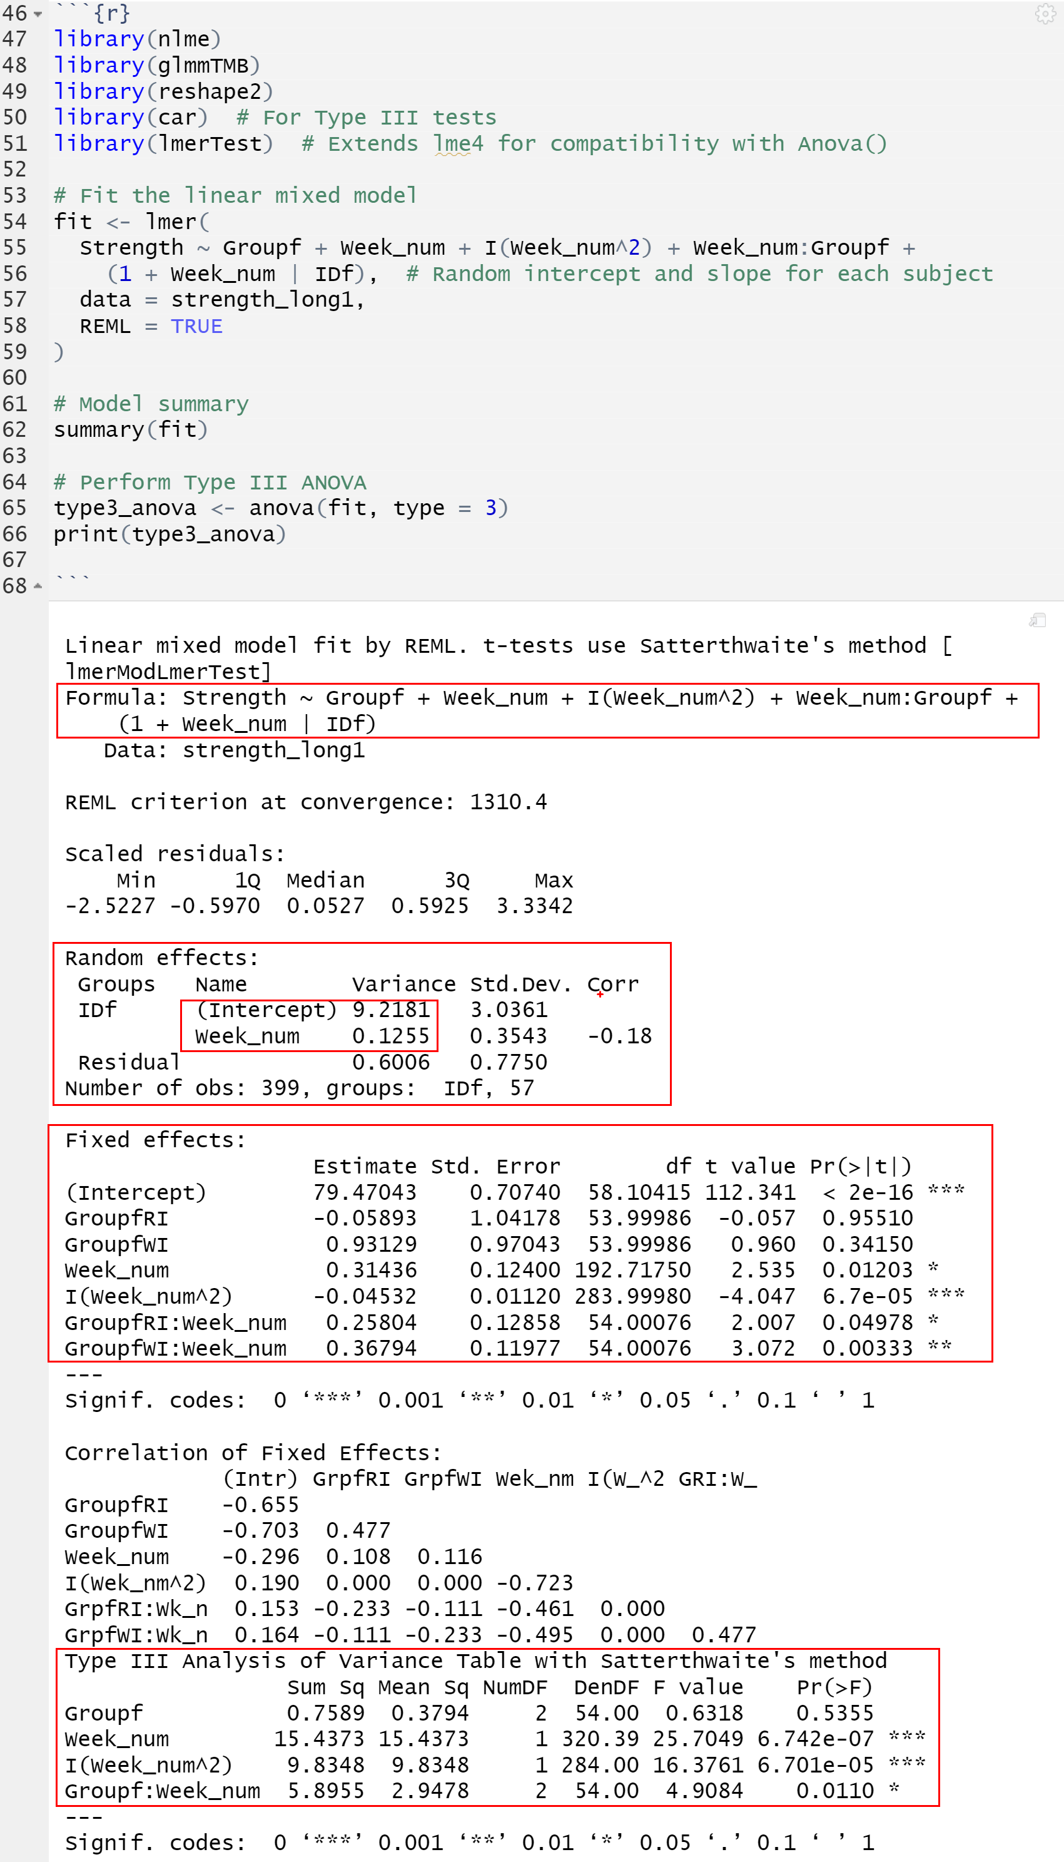

3. Est. variance of the random intercept: **b0i = 9.2181.**

Random effects: 
Groups 
IDf 
Resi dual 
Number of 
Name 
vari ance 
(Intercept) 9. PI 81 
week—num 
0.1255 
o .6006 
std . Dev. 
3.0361 
0.3543 
0.7750 
corr 
-0.18 
obs: 399, groups: 
IDf , 

4. Este.variance of the random slope: **b1i (tij): 0.1255.**

**5.**

* Variance of the Random Intercept (9.2181): There is substantial variability in baseline strength between individuals. On average, individuals differ from the population-average baseline by approximately sqrt(9.2181) units of strength. Thus, when Week = 0, baseline strength is highly variable between individuals, indicating significant heterogeneity in starting strength levels.
* Variance of the Random Slope (0.1255): On average, individuals differ in their rate of change by approximately sqrt(0.1255) units of strength per unit of time. The variability in individual growth rates (random slopes) over time is relatively smaller compared to the variability in baseline strength, indicating that while individuals start at different strength levels, their rates of growth (or decline) are more similar.

**🡺 random intercept variance (9.2181)** >> **random slope variance (0.1255)**: that most of the variability among individuals comes from differences in their baseline strength rather than differences in how their strength changes over time.

**6.**

7. Use ML.

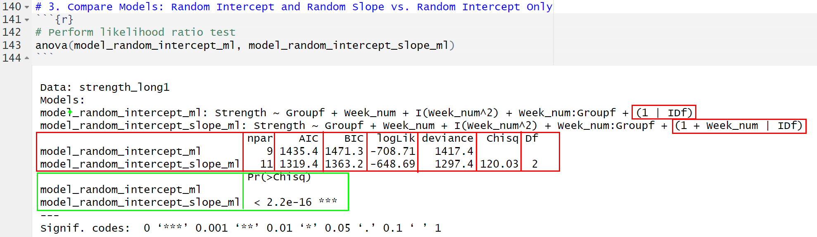

* The model_random_intercept_slope_ml has a lower AIC and BIC compared to the model_random_intercept_ml (random intercept-only), thus better fit.
* Likelihood ratio test:

H0: σb1i2 = 0, H1: σb1i2 > 0 .

Reject H0 (p < 2.2×10^−16). The random slop is not zero.

The inclusion of a random slope is statistically significant and substantially improves the model.

Thus, **no, the random intercept-only model is not defensible. The** random intercept and slope model (model_random_intercept_slope_ml) has a significantly better fit compared to the random intercept-only model (model_random_intercept_ml).

8. Use REML

**Explanation of the Difference:**

* Conditional Variance Var(Yi1∣bi): **variability within a subject**, the **subject-specific** random effects. It includes only the residual variance σε2 ​.
* Marginal Variance Var(Yi1): **overall variability across all subjects and time points**. It includes the variability due to both the random intercept (σb02), random slope(σb12), cov(b0i, b1i), and σε2.

The marginal variance is larger because it accounts for **between-subject** variability in addition to **within-subject** variability.

9.

Using the **model with random intercept and random slop**, the Week*Group interactions are **statistically significant for both the RI and WI groups.** This indicates that the growth trends over time differ significantly across groups.

**Comparison to HW3 (AR(1) Model):**

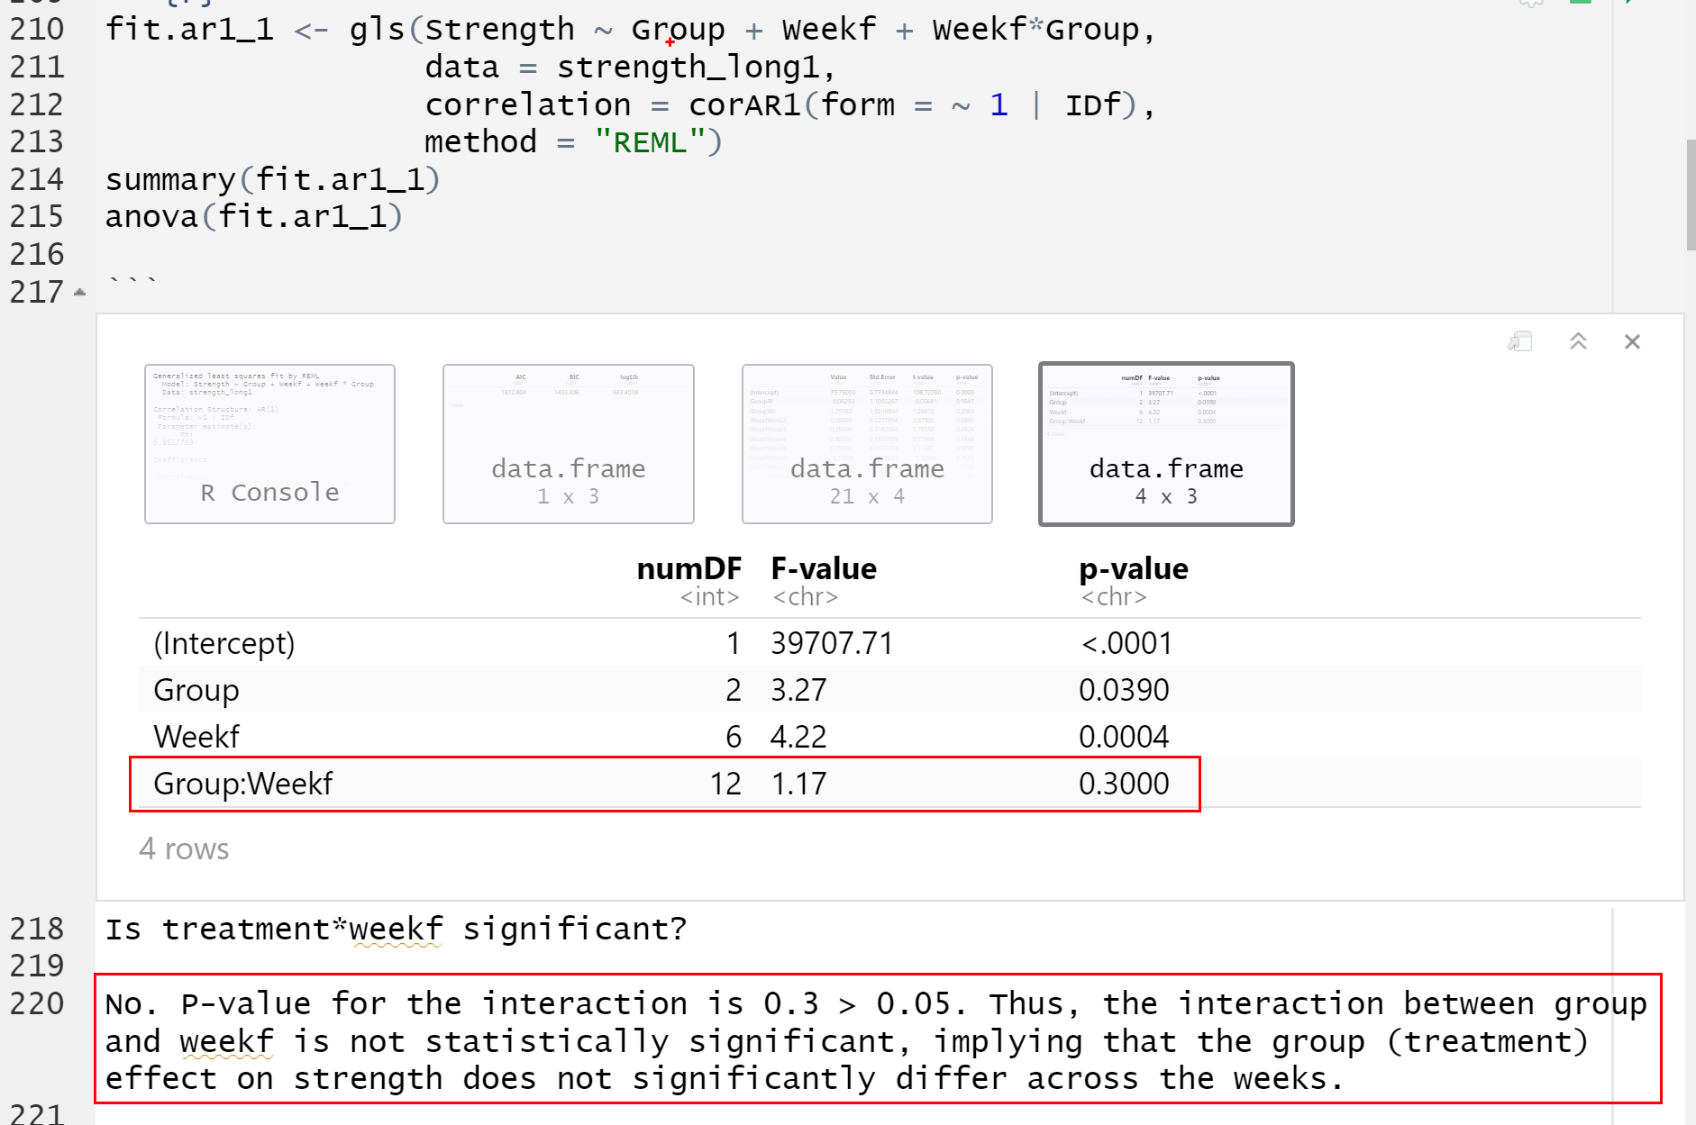

**HW3:** The week*program interaction was **not significant** (p > 0.05) using the AR(1) structure. If using AR(1) with polynomial, only the linear trend shows significant differences between treatment groups.

10. Nested without grand mean

* Linear Trends: significant for both RI and WI groups
* Quadratic Trends: significant for RI and marginally significant WI groups
* Both linear and quadratic trends significantly contribute to the strength data with this random parameter model.

**Comparison to HW3, AR(1) nested Model:**

With the AR(1) nested model, linear and quadratic trends were found to significantly vary across groups over time. However, when examining each group individually, group-specific trend significance was not consistently observed. While the linear trend for the RI group is significant and marginally significant for the WI group, quadratic trends were not significant for any group in the HW3 AR(1) nested model. The random parameter model, however, provides a better fit by capturing both linear and quadratic trends more effectively. This improvement is due to its enhanced handling of random effects, incorporating subject-specific slopes and intercepts to better account for variability across groups and individuals.

11.

* CONT Group: Marginally significant quadratic trend without showing linear trend

**Y.hatCONT(t) = β0CONT + β2CONT = 79.60714 − 0.03393⋅t2**

* RI Group: Significant both Linear and quadratic

**Y.hatRI(t) = β0RI + β1RI + β2RI = 79.08036 + 0.79315⋅t − 0.07292⋅t2**

* WI Group: Significantly Linear trend and marginally significant quadratic trend

**Y.hatWI(t) = β0RI + β1RI + β2RI = 80.52381 + 0.60091⋅t − 0.03515⋅t2**

**HW3:**

**Comparison to HW3 Nested Model Results: The marginally significant quadratic trends for both CONT and WI groups are not captured with the AR(1)_nested model in HW3.**

12. ^YRI(t) = 79.08036 + 0.79315⋅t − 0.07292⋅t2

Vertex for the quadratic curve for RI = (0.79315)/ (2*(-0.07292)) = -5.43849424026

The week at which the max strength is achieved for the RI group is ~ 5.44 week. Since the data is observed to t = 7, **yes, this vertex is within the scope of the model**.

13.^YWI(t) = 80.52381 + 0.60091⋅t **− 0.03515⋅t2**

**OLS Estimates:**

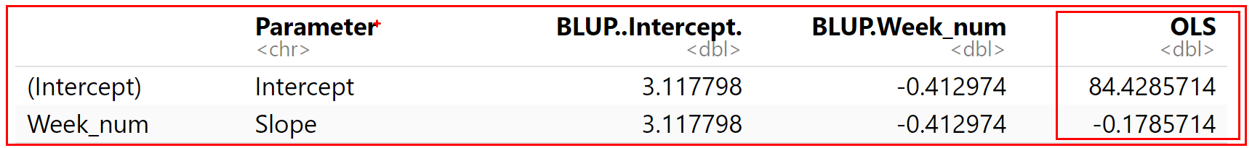

**BLUP Estimates:**

* Adjusted BLUP Intercept (WI, Subject 1) = Fixed Intercept (WI)+BLUP Intercept

= 80.52381 + 3.117798 **= 83.64161**

* Adjusted BLUP Slope (WI, Subject 1) = Fixed Slope (WI)+BLUP Slope

= 0.60091−0.412974 **= 0.187936**

The BLUP Adjusted Intercept and Slope provide a balanced estimate by combining the subject-specific variability and the population-level fixed effects. The differences arise because the BLUP accounts for both fixed effects and random effects (subject-specific variations), while the OLS is fitted solely to the data of Subject 1. The BLUP incorporates shrinkage towards the population mean, making it more robust in cases with fewer data points for individual subjects.

 14.

15.

HW5_longitudinal_2

Jiseon Yang

2024-11-25

# Data

# Load necessary libraries  
library(nlme)  
library(glmmTMB)  
library(reshape2)  
  
# Load the data  
strength_wide1 <- read.csv("C:/Users/jyang/OneDrive - Arizona State University/10 Classes_OneDrive/2024 8F_STP598_Logitudinal/zz HW/Longitudinal_HW3/strength.csv", header = FALSE)  
names(strength_wide1) <- c("ID", "Group", "Week1", "Week2", "Week3", "Week4", "Week5", "Week6", "Week7")  
  
# Convert data from wide format to long format  
strength_long1 <- melt(strength_wide1, id.vars = c("ID", "Group"),  
 variable.name = "Week", value.name = "Strength")  
  
# Convert variables to factors  
strength_long1$Weekf <- as.factor(strength_long1$Week)  
strength_long1$IDf <- as.factor(strength_long1$ID)  
strength_long1$Groupf <- as.factor(strength_long1$Group)  
  
# Check levels to prevent errors  
if (length(levels(strength_long1$Groupf)) < 2) stop("Group must have at least two levels.")  
if (length(levels(strength_long1$Weekf)) < 2) stop("Week must have at least two levels.")  
  
# Convert `Week` to numeric after removing the "Week" prefix  
strength_long1$Week_num <- as.numeric(gsub("Week", "", strength_long1$Weekf))  
  
# Remove rows with missing values  
strength_long1 <- na.omit(strength_long1)

# Question 2

## Use REML estimation and fit a linear mixed model for growth curves with random intercept and random linear slope. Include main effect for program, linear time trend, linear time by program interaction, and quadratic time trend as fixed effects.

# library(nlme)  
# library(glmmTMB)  
# library(reshape2)  
# library(car) # For Type III tests  
# library(lmerTest) # Extends lme4 for compatibility with Anova()  
library(lme4)

## Loading required package: Matrix

##   
## Attaching package: 'lme4'

## The following object is masked from 'package:nlme':  
##   
## lmList

# Fit the linear mixed model  
fit <- lmer(  
 Strength ~ Groupf + Week_num + I(Week_num^2) + Week_num:Groupf +   
 (1 + Week_num | IDf), # Random intercept and slope for each subject  
 data = strength_long1,  
 REML = TRUE  
)  
  
# Model summary  
summary(fit)

## Linear mixed model fit by REML ['lmerMod']  
## Formula: Strength ~ Groupf + Week_num + I(Week_num^2) + Week_num:Groupf +   
## (1 + Week_num | IDf)  
## Data: strength_long1  
##   
## REML criterion at convergence: 1310.4  
##   
## Scaled residuals:   
## Min 1Q Median 3Q Max   
## -2.5227 -0.5970 0.0527 0.5925 3.3342   
##   
## Random effects:  
## Groups Name Variance Std.Dev. Corr   
## IDf (Intercept) 9.2181 3.0361   
## Week_num 0.1255 0.3543 -0.18  
## Residual 0.6006 0.7750   
## Number of obs: 399, groups: IDf, 57  
##   
## Fixed effects:  
## Estimate Std. Error t value  
## (Intercept) 79.47043 0.70740 112.341  
## GroupfRI -0.05893 1.04178 -0.057  
## GroupfWI 0.93129 0.97043 0.960  
## Week_num 0.31436 0.12400 2.535  
## I(Week_num^2) -0.04532 0.01120 -4.047  
## GroupfRI:Week_num 0.25804 0.12858 2.007  
## GroupfWI:Week_num 0.36794 0.11977 3.072  
##   
## Correlation of Fixed Effects:  
## (Intr) GrpfRI GrpfWI Wek_nm I(W_^2 GRI:W_  
## GroupfRI -0.655   
## GroupfWI -0.703 0.477   
## Week_num -0.296 0.108 0.116   
## I(Wek_nm^2) 0.190 0.000 0.000 -0.723   
## GrpfRI:Wk_n 0.153 -0.233 -0.111 -0.461 0.000   
## GrpfWI:Wk_n 0.164 -0.111 -0.233 -0.495 0.000 0.477

# Perform Type III ANOVA  
type3_anova <- anova(fit, type = 3)

## Warning in anova.merMod(fit, type = 3): additional arguments ignored: 'type'

print(type3_anova)

## Analysis of Variance Table  
## npar Sum Sq Mean Sq F value  
## Groupf 2 1.9101 0.9550 1.5902  
## Week_num 1 5.9468 5.9468 9.9021  
## I(Week_num^2) 1 9.8348 9.8348 16.3761  
## Groupf:Week_num 2 5.8955 2.9478 4.9084

library(ggplot2)  
  
ggplot(strength_long1, aes(x = Week_num, y = Strength, color = Groupf, group = IDf)) +  
 geom_line(alpha = 0.5) +  
 labs(title = "Individual Growth Curves by Group",  
 x = "Week",  
 y = "Strength") +  
 theme_minimal()

ggplot(strength_long1, aes(x = Week_num, y = Strength, color = Groupf)) +  
 stat_summary(fun = mean, geom = "line", size = 1) +  
 labs(title = "Group-level Trends",  
 x = "Week",  
 y = "Average Strength") +  
 theme_minimal()

## Warning: Using `size` aesthetic for lines was deprecated in ggplot2 3.4.0.  
## ℹ Please use `linewidth` instead.  
## This warning is displayed once every 8 hours.  
## Call `lifecycle::last_lifecycle_warnings()` to see where this warning was  
## generated.

# Question 6

# Extract the random effects variance-covariance matrix D (for intercept and slope)  
D <- matrix(c(9.2181, -0.18 * sqrt(9.2181 * 0.1255),   
 -0.18 * sqrt(9.2181 * 0.1255), 0.1255), nrow = 2)  
D

## [,1] [,2]  
## [1,] 9.2181000 -0.1936043  
## [2,] -0.1936043 0.1255000

# Define Z_i for 7 time points (1 column for intercept, 1 column for slope)  
time_points <- 1:7  
Z_i <- cbind(1, time_points)  
Z_i

## time_points  
## [1,] 1 1  
## [2,] 1 2  
## [3,] 1 3  
## [4,] 1 4  
## [5,] 1 5  
## [6,] 1 6  
## [7,] 1 7

# Calculate Zi * D * Zi'  
Zi_D_Zi_t <- Z_i %*% D %*% t(Z_i)  
Zi_D_Zi_t

## [,1] [,2] [,3] [,4] [,5] [,6] [,7]  
## [1,] 8.956391 8.888287 8.820183 8.752078 8.683974 8.615870 8.547765  
## [2,] 8.888287 8.945683 9.003078 9.060474 9.117870 9.175265 9.232661  
## [3,] 8.820183 9.003078 9.185974 9.368870 9.551765 9.734661 9.917557  
## [4,] 8.752078 9.060474 9.368870 9.677265 9.985661 10.294057 10.602452  
## [5,] 8.683974 9.117870 9.551765 9.985661 10.419557 10.853452 11.287348  
## [6,] 8.615870 9.175265 9.734661 10.294057 10.853452 11.412848 11.972244  
## [7,] 8.547765 9.232661 9.917557 10.602452 11.287348 11.972244 12.657139

# Add the residual variance (Ri)  
Ri <- diag(0.6006, nrow = 7, ncol = 7)  
Ri

## [,1] [,2] [,3] [,4] [,5] [,6] [,7]  
## [1,] 0.6006 0.0000 0.0000 0.0000 0.0000 0.0000 0.0000  
## [2,] 0.0000 0.6006 0.0000 0.0000 0.0000 0.0000 0.0000  
## [3,] 0.0000 0.0000 0.6006 0.0000 0.0000 0.0000 0.0000  
## [4,] 0.0000 0.0000 0.0000 0.6006 0.0000 0.0000 0.0000  
## [5,] 0.0000 0.0000 0.0000 0.0000 0.6006 0.0000 0.0000  
## [6,] 0.0000 0.0000 0.0000 0.0000 0.0000 0.6006 0.0000  
## [7,] 0.0000 0.0000 0.0000 0.0000 0.0000 0.0000 0.6006

# covariance matrix Σi(α)  
Sigma_i_alpha <- Zi_D_Zi_t + Ri  
  
# Print   
Sigma_i_alpha

## [,1] [,2] [,3] [,4] [,5] [,6] [,7]  
## [1,] 9.556991 8.888287 8.820183 8.752078 8.683974 8.615870 8.547765  
## [2,] 8.888287 9.546283 9.003078 9.060474 9.117870 9.175265 9.232661  
## [3,] 8.820183 9.003078 9.786574 9.368870 9.551765 9.734661 9.917557  
## [4,] 8.752078 9.060474 9.368870 10.277865 9.985661 10.294057 10.602452  
## [5,] 8.683974 9.117870 9.551765 9.985661 11.020157 10.853452 11.287348  
## [6,] 8.615870 9.175265 9.734661 10.294057 10.853452 12.013448 11.972244  
## [7,] 8.547765 9.232661 9.917557 10.602452 11.287348 11.972244 13.257739

# Question 7

## 1. Estimating the Model with Random Intercept and Random Slope (using ML)

# Fit model with random intercept and random slope using ML  
model_random_intercept_slope_ml <- lmer(Strength ~ Groupf + Week_num + I(Week_num^2) + Week_num:Groupf +   
 (1 + Week_num | IDf), data = strength_long1, REML = FALSE)  
  
# Summary of the model  
summary(model_random_intercept_slope_ml)

## Linear mixed model fit by maximum likelihood ['lmerMod']  
## Formula: Strength ~ Groupf + Week_num + I(Week_num^2) + Week_num:Groupf +   
## (1 + Week_num | IDf)  
## Data: strength_long1  
##   
## AIC BIC logLik deviance df.resid   
## 1319.4 1363.3 -648.7 1297.4 388   
##   
## Scaled residuals:   
## Min 1Q Median 3Q Max   
## -2.5322 -0.5923 0.0551 0.5935 3.3435   
##   
## Random effects:  
## Groups Name Variance Std.Dev. Corr   
## IDf (Intercept) 8.7119 2.9516   
## Week_num 0.1178 0.3433 -0.18  
## Residual 0.5984 0.7736   
## Number of obs: 399, groups: IDf, 57  
##   
## Fixed effects:  
## Estimate Std. Error t value  
## (Intercept) 79.47043 0.68918 115.312  
## GroupfRI -0.05893 1.01399 -0.058  
## GroupfWI 0.93129 0.94455 0.986  
## Week_num 0.31436 0.12231 2.570  
## I(Week_num^2) -0.04532 0.01118 -4.054  
## GroupfRI:Week_num 0.25804 0.12515 2.062  
## GroupfWI:Week_num 0.36794 0.11658 3.156  
##   
## Correlation of Fixed Effects:  
## (Intr) GrpfRI GrpfWI Wek_nm I(W_^2 GRI:W_  
## GroupfRI -0.654   
## GroupfWI -0.702 0.477   
## Week_num -0.299 0.106 0.114   
## I(Wek_nm^2) 0.195 0.000 0.000 -0.731   
## GrpfRI:Wk_n 0.153 -0.233 -0.111 -0.455 0.000   
## GrpfWI:Wk_n 0.164 -0.111 -0.233 -0.488 0.000 0.477

anova(model_random_intercept_slope_ml)

## Analysis of Variance Table  
## npar Sum Sq Mean Sq F value  
## Groupf 2 2.0091 1.0046 1.6786  
## Week_num 1 6.2551 6.2551 10.4521  
## I(Week_num^2) 1 9.8348 9.8348 16.4338  
## Groupf:Week_num 2 6.2011 3.1006 5.1810

## 2. Estimating the Model with Only Random Intercept (using ML)

# Fit model with random intercept only using ML  
model_random_intercept_ml <- lmer(Strength ~ Groupf + Week_num + I(Week_num^2) + Week_num:Groupf +   
 (1 | IDf), data = strength_long1, REML = FALSE)  
  
# Summary of the model  
summary(model_random_intercept_ml)

## Linear mixed model fit by maximum likelihood ['lmerMod']  
## Formula: Strength ~ Groupf + Week_num + I(Week_num^2) + Week_num:Groupf +   
## (1 | IDf)  
## Data: strength_long1  
##   
## AIC BIC logLik deviance df.resid   
## 1435.4 1471.3 -708.7 1417.4 390   
##   
## Scaled residuals:   
## Min 1Q Median 3Q Max   
## -2.9574 -0.6224 0.0031 0.5946 3.3902   
##   
## Random effects:  
## Groups Name Variance Std.Dev.  
## IDf (Intercept) 9.096 3.016   
## Residual 1.148 1.072   
## Number of obs: 399, groups: IDf, 57  
##   
## Fixed effects:  
## Estimate Std. Error t value  
## (Intercept) 79.47043 0.72825 109.126  
## GroupfRI -0.05893 1.05620 -0.056  
## GroupfWI 0.93129 0.98387 0.947  
## Week_num 0.31436 0.13191 2.383  
## I(Week_num^2) -0.04532 0.01549 -2.926  
## GroupfRI:Week_num 0.25804 0.06793 3.799  
## GroupfWI:Week_num 0.36794 0.06327 5.815  
##   
## Correlation of Fixed Effects:  
## (Intr) GrpfRI GrpfWI Wek_nm I(W_^2 GRI:W_  
## GroupfRI -0.645   
## GroupfWI -0.692 0.477   
## Week_num -0.325 0.059 0.063   
## I(Wek_nm^2) 0.255 0.000 0.000 -0.939   
## GrpfRI:Wk_n 0.166 -0.257 -0.123 -0.229 0.000   
## GrpfWI:Wk_n 0.178 -0.123 -0.257 -0.246 0.000 0.477

anova(model_random_intercept_ml)

## Analysis of Variance Table  
## npar Sum Sq Mean Sq F value  
## Groupf 2 7.431 3.715 3.2354  
## Week_num 1 40.742 40.742 35.4783  
## I(Week_num^2) 1 9.835 9.835 8.5641  
## Groupf:Week_num 2 40.391 20.196 17.5862

## 3. Compare Models: Random Intercept and Random Slope vs. Random Intercept Only

# Perform likelihood ratio test  
anova(model_random_intercept_ml, model_random_intercept_slope_ml)

## Data: strength_long1  
## Models:  
## model_random_intercept_ml: Strength ~ Groupf + Week_num + I(Week_num^2) + Week_num:Groupf + (1 | IDf)  
## model_random_intercept_slope_ml: Strength ~ Groupf + Week_num + I(Week_num^2) + Week_num:Groupf + (1 + Week_num | IDf)  
## npar AIC BIC logLik deviance Chisq Df  
## model_random_intercept_ml 9 1435.4 1471.3 -708.71 1417.4   
## model_random_intercept_slope_ml 11 1319.4 1363.2 -648.69 1297.4 120.03 2  
## Pr(>Chisq)   
## model_random_intercept_ml   
## model_random_intercept_slope_ml < 2.2e-16 ***  
## ---  
## Signif. codes: 0 '***' 0.001 '**' 0.01 '*' 0.05 '.' 0.1 ' ' 1

# Question 8

# Refit the random intercept and random slope model using REML  
model_random_intercept_slope_reml <- lmer(Strength ~ Groupf + Week_num + I(Week_num^2) + Week_num:Groupf +   
 (1 + Week_num | IDf), data = strength_long1, REML = TRUE)  
summary(model_random_intercept_slope_reml)

## Linear mixed model fit by REML ['lmerMod']  
## Formula: Strength ~ Groupf + Week_num + I(Week_num^2) + Week_num:Groupf +   
## (1 + Week_num | IDf)  
## Data: strength_long1  
##   
## REML criterion at convergence: 1310.4  
##   
## Scaled residuals:   
## Min 1Q Median 3Q Max   
## -2.5227 -0.5970 0.0527 0.5925 3.3342   
##   
## Random effects:  
## Groups Name Variance Std.Dev. Corr   
## IDf (Intercept) 9.2181 3.0361   
## Week_num 0.1255 0.3543 -0.18  
## Residual 0.6006 0.7750   
## Number of obs: 399, groups: IDf, 57  
##   
## Fixed effects:  
## Estimate Std. Error t value  
## (Intercept) 79.47043 0.70740 112.341  
## GroupfRI -0.05893 1.04178 -0.057  
## GroupfWI 0.93129 0.97043 0.960  
## Week_num 0.31436 0.12400 2.535  
## I(Week_num^2) -0.04532 0.01120 -4.047  
## GroupfRI:Week_num 0.25804 0.12858 2.007  
## GroupfWI:Week_num 0.36794 0.11977 3.072  
##   
## Correlation of Fixed Effects:  
## (Intr) GrpfRI GrpfWI Wek_nm I(W_^2 GRI:W_  
## GroupfRI -0.655   
## GroupfWI -0.703 0.477   
## Week_num -0.296 0.108 0.116   
## I(Wek_nm^2) 0.190 0.000 0.000 -0.723   
## GrpfRI:Wk_n 0.153 -0.233 -0.111 -0.461 0.000   
## GrpfWI:Wk_n 0.164 -0.111 -0.233 -0.495 0.000 0.477

anova(model_random_intercept_slope_reml)

## Analysis of Variance Table  
## npar Sum Sq Mean Sq F value  
## Groupf 2 1.9101 0.9550 1.5902  
## Week_num 1 5.9468 5.9468 9.9021  
## I(Week_num^2) 1 9.8348 9.8348 16.3761  
## Groupf:Week_num 2 5.8955 2.9478 4.9084

# Question10-11

# Fit the nested model without grand mean  
nested_model <-   
 lmer(Strength ~ -1 + Groupf + Week_num:Groupf + I(Week_num^2):Groupf +   
 (1 + Week_num | IDf), data = strength_long1, REML = TRUE)  
  
summary(nested_model)

## Linear mixed model fit by REML ['lmerMod']  
## Formula: Strength ~ -1 + Groupf + Week_num:Groupf + I(Week_num^2):Groupf +   
## (1 + Week_num | IDf)  
## Data: strength_long1  
##   
## REML criterion at convergence: 1319  
##   
## Scaled residuals:   
## Min 1Q Median 3Q Max   
## -2.5978 -0.5905 0.0316 0.5671 3.1938   
##   
## Random effects:  
## Groups Name Variance Std.Dev. Corr   
## IDf (Intercept) 9.2187 3.0362   
## Week_num 0.1255 0.3543 -0.18  
## Residual 0.5998 0.7744   
## Number of obs: 399, groups: IDf, 57  
##   
## Fixed effects:  
## Estimate Std. Error t value  
## GroupfCONT 79.60714 0.73059 108.963  
## GroupfRI 79.08036 0.81683 96.814  
## GroupfWI 80.52381 0.71298 112.939  
## GroupfCONT:Week_num 0.22321 0.17377 1.285  
## GroupfRI:Week_num 0.79315 0.19428 4.083  
## GroupfWI:Week_num 0.60091 0.16958 3.543  
## GroupfCONT:I(Week_num^2) -0.03393 0.01889 -1.796  
## GroupfRI:I(Week_num^2) -0.07292 0.02112 -3.452  
## GroupfWI:I(Week_num^2) -0.03515 0.01844 -1.906  
##   
## Correlation of Fixed Effects:  
## GrCONT GrpfRI GrpfWI GCONT:W GRI:W_ GWI:W_ GCONT:I GRI:I(  
## GroupfRI 0.000   
## GroupfWI 0.000 0.000   
## GrpfCONT:W_ -0.379 0.000 0.000   
## GrpfRI:Wk_n 0.000 -0.379 0.000 0.000   
## GrpfWI:Wk_n 0.000 0.000 -0.379 0.000 0.000   
## GCONT:I(W_^ 0.310 0.000 0.000 -0.870 0.000 0.000   
## GRI:I(W_^2) 0.000 0.310 0.000 0.000 -0.870 0.000 0.000   
## GWI:I(W_^2) 0.000 0.000 0.310 0.000 0.000 -0.870 0.000 0.000

anova(nested_model)

## Analysis of Variance Table  
## npar Sum Sq Mean Sq F value  
## Groupf 3 24376.5 8125.5 13547.8101  
## Groupf:Week_num 3 11.8 3.9 6.5729  
## Groupf:I(Week_num^2) 3 11.3 3.8 6.2574

# Question 13

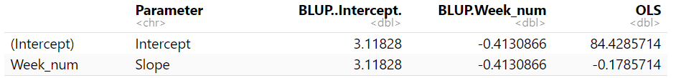

library(lme4)  
  
# Fit the mixed-effects model with random intercept and slope  
model <- lmer(Strength ~ -1 + Groupf + Week_num:Groupf + I(Week_num^2):Groupf +  
 (1 + Week_num | IDf), data = strength_long1, REML = TRUE)  
  
# Step 1: Extract fixed effects for the WI group  
fixed_effects <- fixef(model)  
fixed_intercept_WI <- fixed_effects["GroupfWI"]  
fixed_slope_WI <- fixed_effects["GroupfWI:Week_num"]  
  
# Step 2: Obtain BLUP estimates for all subjects  
blup_estimates <- ranef(model)$IDf  
  
# Step 3: Extract BLUP estimates for the first subject in the WI program  
first_WI_subject <- strength_long1[strength_long1$Groupf == "WI", "IDf"][1]  
blup_first_WI <- as.numeric(blup_estimates[first_WI_subject, ])  
names(blup_first_WI) <- colnames(blup_estimates) # Ensure column names match  
  
cat("\nBLUP estimates for WI, Subject 1:\n")

##   
## BLUP estimates for WI, Subject 1:

print(blup_first_WI)

## (Intercept) Week_num   
## 3.1182796 -0.4130866

# Step 4: Calculate Adjusted BLUP Intercept and Slope  
adjusted_intercept <- fixed_intercept_WI + blup_first_WI["(Intercept)"]  
adjusted_slope <- fixed_slope_WI + blup_first_WI["Week_num"]  
cat("\nAdjusted BLUP Intercept (WI, Subject 1):", adjusted_intercept, "\n")

##   
## Adjusted BLUP Intercept (WI, Subject 1): 83.64209

cat("Adjusted BLUP Slope (WI, Subject 1):", adjusted_slope, "\n")

## Adjusted BLUP Slope (WI, Subject 1): 0.1878204

# Step 5: Fit an OLS model to the data of the first subject  
first_subject_data <- subset(strength_long1, IDf == first_WI_subject)  
ols_model <- lm(Strength ~ Week_num, data = first_subject_data)  
ols_coefficients <- coef(ols_model)  
cat("\nOLS estimates for WI, Subject 1:\n")

##   
## OLS estimates for WI, Subject 1:

print(ols_coefficients)

## (Intercept) Week_num   
## 84.4285714 -0.1785714

# Step 6: Compare the BLUP Adjusted Intercept/Slope and OLS results  
comparison <- data.frame(  
 Parameter = c("Intercept", "Slope"),  
 BLUP_Adjusted = c(adjusted_intercept, adjusted_slope),  
 OLS = c(ols_coefficients[1], ols_coefficients[2])  
)  
cat("\nComparison of Adjusted BLUP and OLS estimates for WI, Subject 1:\n")

##   
## Comparison of Adjusted BLUP and OLS estimates for WI, Subject 1:

print(comparison)

## Parameter BLUP_Adjusted OLS  
## GroupfWI Intercept 83.6420891 84.4285714  
## GroupfWI:Week_num Slope 0.1878204 -0.1785714

The BLUP Adjusted Intercept and Slope provide a balanced estimate by combining the subject-specific variability and the population-level fixed effects. The differences arise because the BLUP accounts for both fixed effects and random effects (subject-specific variations), while the OLS is fitted solely to the data of Subject 1. The BLUP incorporates shrinkage towards the population mean, making it more robust in cases with fewer data points for individual subjects.